4-42 Main Question (สำหรับแสดงข้อสอบ)

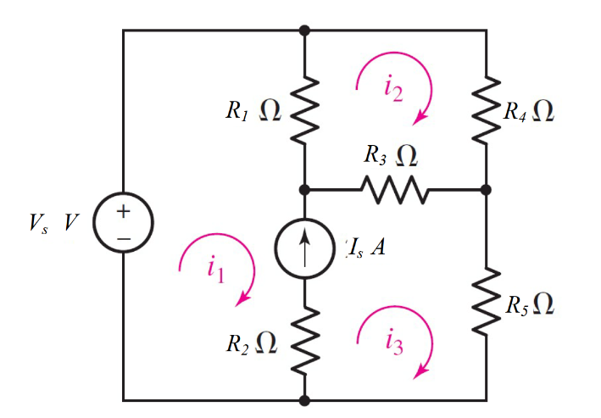

Given *E*1 = 1 V, *Is* = 2 A, *R*1 = 7 Ω, *R*2 = 3 Ω, *R*3 = 3 Ω., *R*4 = 1 Ω, *R*5 = 2 Ω..

Find

Variables (สำหรับเขียนโค้ดเพื่อหาคำตอบ)

Random variables

E1 = {1:5}; Is = {1:5};

R1 = {5:10}; R2 = {1:5}; R3 = {1:5}; R4 = {1:5}; R5 = {1:5};

Global variables

#E1 = 1; Is = 2;

R1 = 7; R2 = 3; R3 = 3; R4 = 1; R5 =2;

Z11 = R1; Z12 = -R1-R3; Z13 = R3+R5;

Z21 = -R1; Z22 = R1+R3+R4; Z23 = -R3;

Z31 = -1; Z32 = 0; Z33 = 1;

V1 = E1; V2 = 0; V3 = Is;

D = Z11*Z22*Z33+Z12*Z23*Z31+Z13*Z21*Z32-Z31*Z22*Z13-Z32*Z23*Z11-Z33*Z21*Z12;

D1 = V1*Z22*Z33+Z12*Z23*V3+Z13*V2*Z32-V3*Z22*Z13-Z32*Z23*V1-Z33*V2*Z12;

D2 = Z11*V2*Z33+V1*Z23*Z31+Z13*Z21*V3-Z31*V2*Z13-V3*Z23*Z11-Z33*Z21*V1;

D3 = Z11*Z22*V3+Z12*V2*Z31+V1*Z21*Z32-Z31*Z22*V1-Z32*V2*Z11-V3*Z21*Z12;

I1 = D1/D; I2 = D2/D; I3 = D3/D;

Part (กรอกคำตอบ)

1. *I*1 = I1 = -1.2188 A
2. *I*2 = I2 = -0.5625 A
3. *I3* = I3 = 0.78125 A

4-43 Main Question (สำหรับแสดงข้อสอบ)

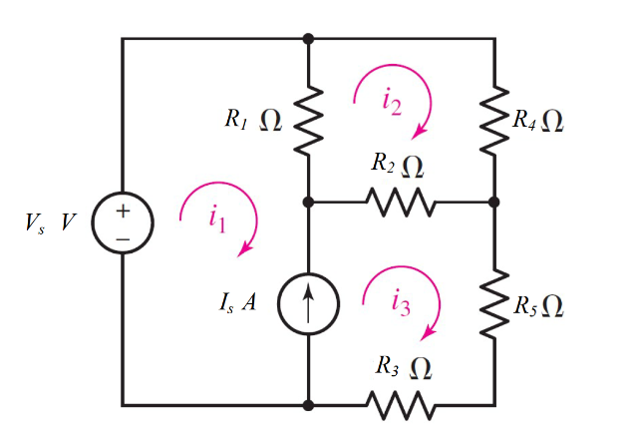

Given *E*1 = 3 V, *Is* = 5 A, *R*1 = 10 Ω, *R*2 = 1 Ω, *R*3 = 17 Ω., *R*4 = 5 Ω, *R*5 = 4 Ω..

Find

Variables (สำหรับเขียนโค้ดเพื่อหาคำตอบ)

Random variables

E1 = {1:5}; Is = {1:5};

R1 = {10:15}; R2 = {1:5}; R3 = {10:20}; R4 = {5:10}; R5 = {1:5};

Global variables

#E1 = 3; Is = 5;

R1 = 10; R2 = 1; R3 = 17; R4 = 5; R5 =4;

Z11 = R1; Z12 = -R1-R2; Z13 = R2+R3+R5;

Z21 = -R1; Z22 = R1+R2+R4; Z23 = -R2;

Z31 = -1; Z32 = 0; Z33 = 1;

V1 = E1; V2 = 0; V3 = Is;

D = Z11*Z22*Z33+Z12*Z23*Z31+Z13*Z21*Z32-Z31*Z22*Z13-Z32*Z23*Z11-Z33*Z21*Z12;

D1 = V1*Z22*Z33+Z12*Z23*V3+Z13*V2*Z32-V3*Z22*Z13-Z32*Z23*V1-Z33*V2*Z12;

D2 = Z11*V2*Z33+V1*Z23*Z31+Z13*Z21*V3-Z31*V2*Z13-V3*Z23*Z11-Z33*Z21*V1;

D3 = Z11*Z22*V3+Z12*V2*Z31+V1*Z21*Z32-Z31*Z22*V1-Z32*V2*Z11-V3*Z21*Z12;

I1 = D1/D; I2 = D2/D; I3 = D3/D;

Part (กรอกคำตอบ)

1. *I*1 = I1 = -4.2379 A
2. *I*2 = I2 = -2.601 A
3. *I3* = I3 = 0.7621 A

4-44 Main Question (สำหรับแสดงข้อสอบ)

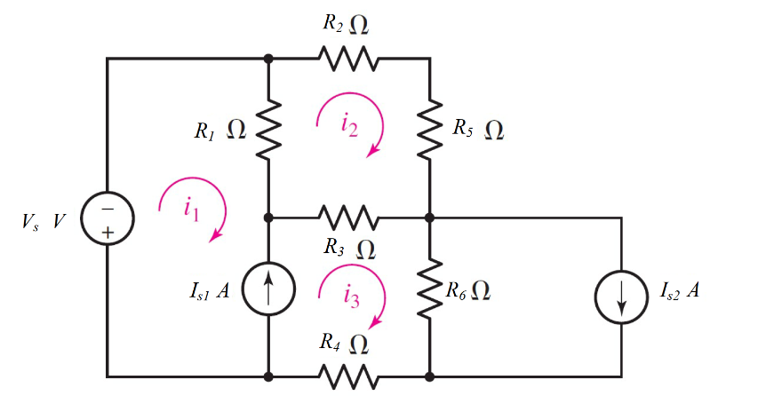

Given *E*1 = 7 V, *Is1* = 9 A, *Is2* = 3 A, *R*1 = 5 Ω, *R*2 = 3 Ω, *R*3 = 11 Ω., *R*4 = 5 Ω, *R*5 = 10 Ω,

*R*6 = 1 Ω.

Find

Variables (สำหรับเขียนโค้ดเพื่อหาคำตอบ)

Random variables

E1 = {5:10}; Is1 = {5:10}; Is2 = {1:5};

R1 = {1:5}; R2 = {1:5}; R3 = {10:15}; R4 = {5:10}; R5 = {5:10};

Global variables

#E1 = 7; Is1 = 9; Is2 = 3;

R1 = 5; R2 = 3; R3 = 11; R4 = 5; R5 =10; R6 =1;

Z11 = R1; Z12 = -R1-R3; Z13 = R3+R4+R6;

Z21 = -R1; Z22 = R1+R2+R3+R5; Z23 = -R3;

Z31 = -1; Z32 = 0; Z33 = 1;

V1 = Is2-E1; V2 = 0; V3 = Is1;

D = Z11*Z22*Z33+Z12*Z23*Z31+Z13*Z21*Z32-Z31*Z22*Z13-Z32*Z23*Z11-Z33*Z21*Z12;

D1 = V1*Z22*Z33+Z12*Z23*V3+Z13*V2*Z32-V3*Z22*Z13-Z32*Z23*V1-Z33*V2*Z12;

D2 = Z11*V2*Z33+V1*Z23*Z31+Z13*Z21*V3-Z31*V2*Z13-V3*Z23*Z11-Z33*Z21*V1;

D3 = Z11*Z22*V3+Z12*V2*Z31+V1*Z21*Z32-Z31*Z22*V1-Z32*V2*Z11-V3*Z21*Z12;

I1 = D1/D; I2 = D2/D; I3 = D3/D;

Part (กรอกคำตอบ)

1. *I*1 = I1 = -7.772 A
2. *I*2 = I2 = -0.8743 A
3. *I3* = I3 = 1.2277A

4-47 Main Question (สำหรับแสดงข้อสอบ)

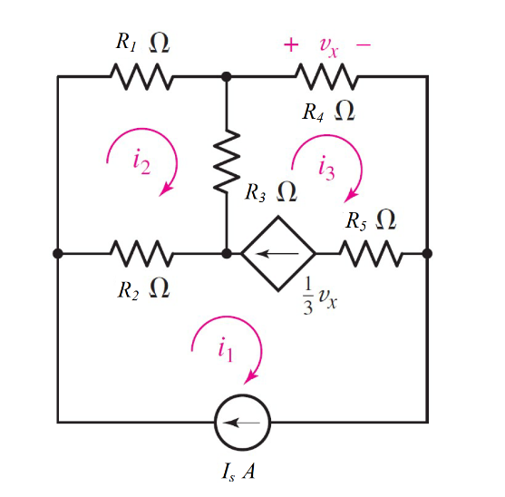

Given *I*s = 5 A, *R*1 = 12 Ω, *R*2 = 13 Ω, *R*3 = 11 Ω, *R*4 = 13 Ω, *R*5 = 12 Ω

Find

Variables (สำหรับเขียนโค้ดเพื่อหาคำตอบ)

Random variables

E1 = {1:5}; Is = {10:15};

R1 = {10:15}; R2 = {10:15}; R3 = {10:15}; R4 = {10:15}; R5 = {10:15};

Global variables

# Is = 5;

R1 = 12; R2 = 13; R3 = 11; R4 = 13; R5 =12;

Z11 = 1; Z12 = 0; Z13 = 0;

Z21 = -1; Z22 = 0; Z23 = (1-13/3);

Z31 = -R2; Z32 = R1+R2+R3; Z33 = -R3;

V1 = Is; V2 = 0; V3 = 0;

D = Z11*Z22*Z33+Z12*Z23*Z31+Z13*Z21*Z32-Z31*Z22*Z13-Z32*Z23*Z11-Z33*Z21*Z12;

D1 = V1*Z22*Z33+Z12*Z23*V3+Z13*V2*Z32-V3*Z22*Z13-Z32*Z23*V1-Z33*V2*Z12;

D2 = Z11*V2*Z33+V1*Z23*Z31+Z13*Z21*V3-Z31*V2*Z13-V3*Z23*Z11-Z33*Z21*V1;

D3 = Z11*Z22*V3+Z12*V2*Z31+V1*Z21*Z32-Z31*Z22*V1-Z32*V2*Z11-V3*Z21*Z12;

I1 = D1/D; I2 = D2/D; I3 = D3/D;

Vx=R4*I3;

Part (กรอกคำตอบ)

1. *I*1 = I1 = 5 A
2. *I*2 = I2 = 1.347 A
3. *I*3 = I3 = -1.5 A
4. *Vx =* Vx = -19.5 V

4.49 Main Question (สำหรับแสดงข้อสอบ)

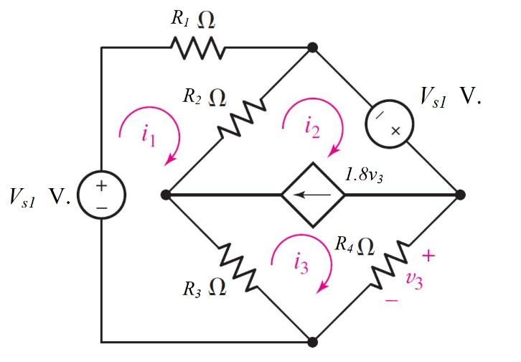

Given *E*1 = 3 V, *E*2 = 5 V, *R*1 = 1 Ω, *R*2 = 4 Ω, *R*3 = 2 Ω, *R*4 = 1 Ω.

Find

Variables (สำหรับเขียนโค้ดเพื่อหาคำตอบ)

Random variables

E1 = {1:5}; E2 = {1:5};

R1 = {1:5}; R2 = {1:5}; R3 = {1:5}; R4 = {1:5};

Global variables

#E1 = 3; E2 = 5; R1 = 1; R2 = 4; R3 = 2; R4 = 1;

Z11 = R1+R2+R3; Z12 = -R2; Z13 = -R3;

Z21 = -R2-R3; Z22 = R2; Z23 = R3+R4;

Z31 = 0; Z32 = 1; Z33 = -2.8;

V1 = E1; V2 = E2; V3 =0;

D = Z11*Z22*Z33+Z12*Z23*Z31+Z13*Z21*Z32-Z31*Z22*Z13-Z32*Z23*Z11-Z33*Z21*Z12;

D1 = V1*Z22*Z33+Z12*Z23*V3+Z13*V2*Z32-V3*Z22*Z13-Z32*Z23*V1-Z33*V2*Z12;

D2 = Z11*V2*Z33+V1*Z23*Z31+Z13*Z21*V3-Z31*V2*Z13-V3*Z23*Z11-Z33*Z21*V1;

D3 = Z11*Z22*V3+Z12*V2*Z31+V1*Z21*Z32-Z31*Z22*V1-Z32*V2*Z11-V3*Z21*Z12;

I1 = D1/D; I2 = D2/D; I3 = D3/D;

v3=R4*I3;

Part (กรอกคำตอบ)

1. *I*1 = I1 = 5.376 A
2. *I*2 = I2 = 1.347 A
3. *I3* = I3 = 2.623 A
4. *V3 =* v3 = 2.623 V.